Janis Gonzalez

WEB 335 Introduction to NoSQL

Assignment 4.2 MongoDB Atlas Setup

April 09,2023

Bellevue University

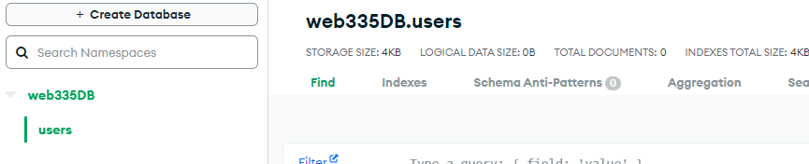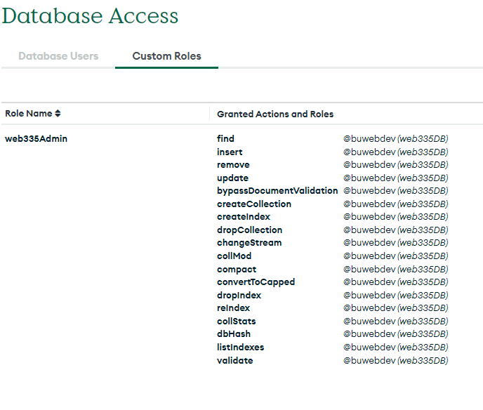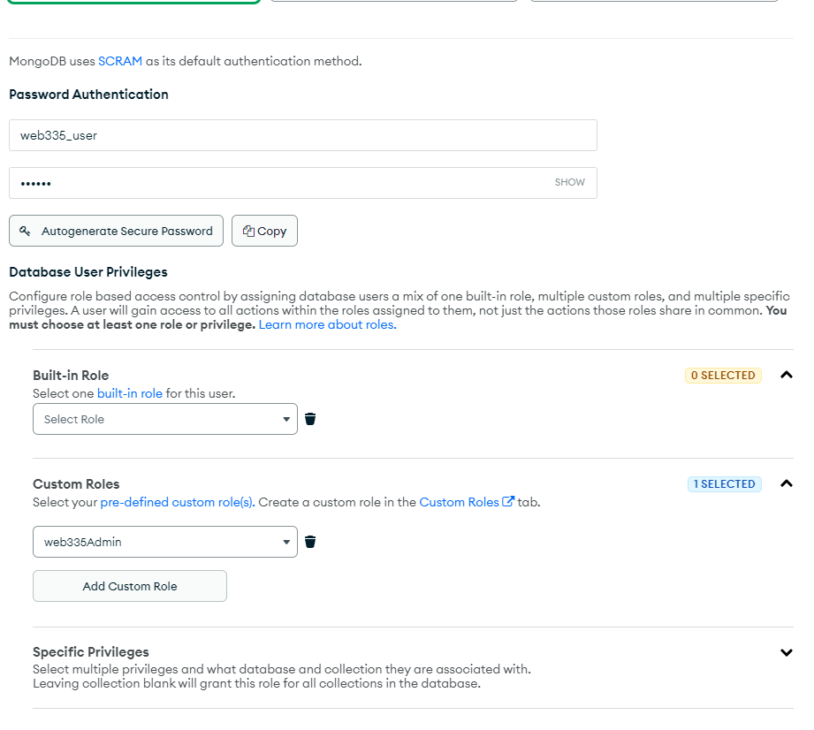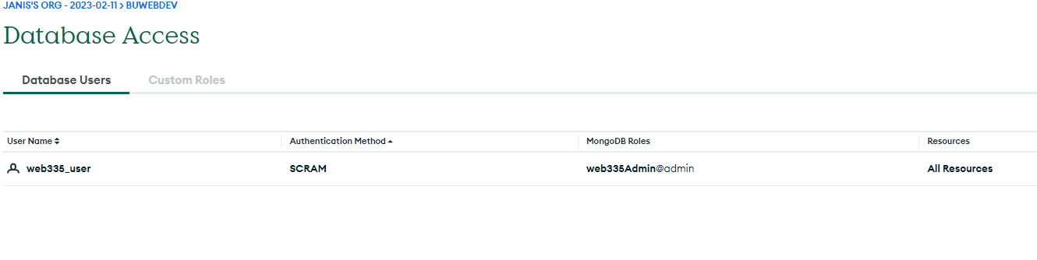

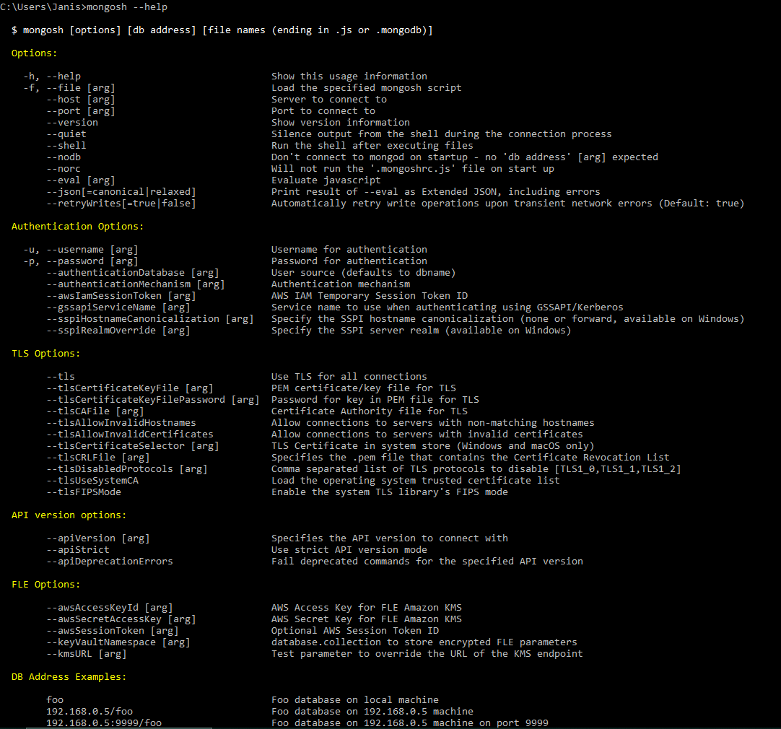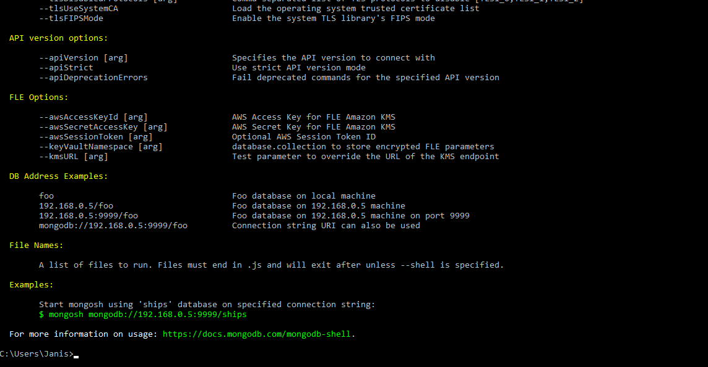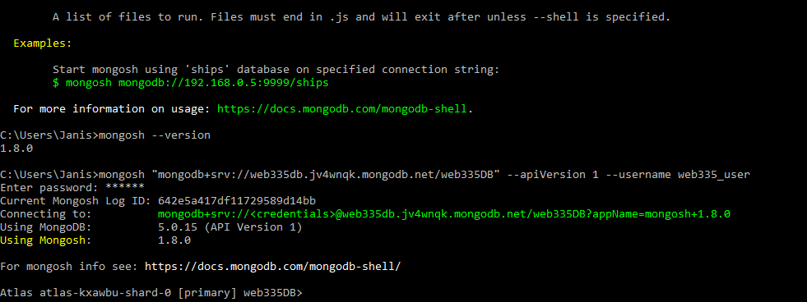

mongosh "mongodb+srv://web335db.jv4wnqk.mongodb.net/web335DB" --apiVersion 1 --username web335_user